**PRAKTIK**

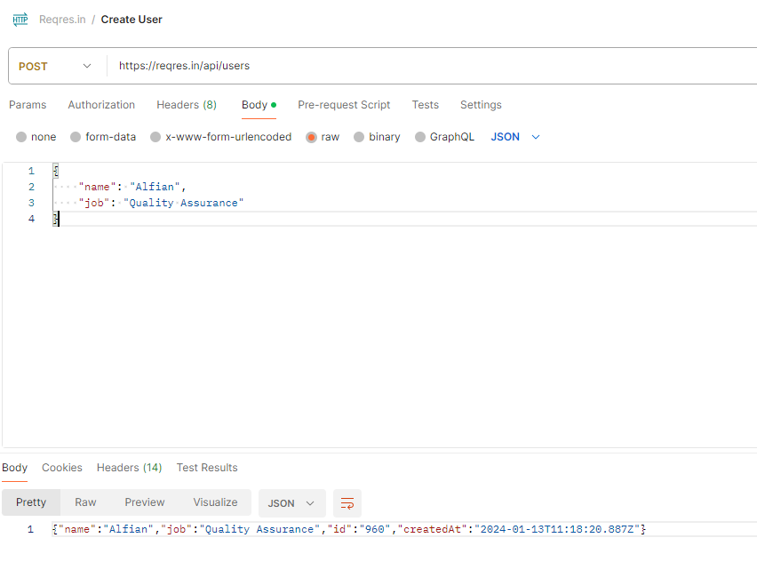

| **Input**  describe('Create New User', () => {  it('Successfully create new user', () => {  var user = {  "name": "Eduwork",  "job": "Education"  }  cy.request('POST', 'https://reqres.in/api/users', user).then((response) => {  expect(response.status).equal(201)  })  });  }); |
| --- |
| **Output** |

**TUGAS**

| **Input**  describe('Create New User', () => {  it('Successfully create new user', () => {  var user = {  "name": "Eduwork",  "job": "Education"  }  cy.request('POST', 'https://reqres.in/api/users', user).then((response) => {  expect(response.status).equal(201)  expect(response.body.name).to.eq(user.name)  expect(response.body.job).to.eq(user.job)  })  });  }); |
| --- |
| **Output** |